# **In-Class Exercise: ROLAP with Tableau**

# Merging a star diagram dataset in Tableau

Follow these steps to pull in the **dimension** and **measure** data for this retail grocery store dataset

1. Open Tableau program
2. Select the *Microsoft Excel* option under the “To a File” portion of the Connect menu.
3. Select the Excel file that is downloadable from today’s module. This will open the Excel file in Tableau and default to the “Data Connections” tab in Tableau. This is where you can select datasets from your data source and even create joins between them. The goal is to join the Sales Fact table to each of the four dimension tables
4. To utilize the dataset in this sample file, first drag the ***Sales Fact*** table into the window on the right.

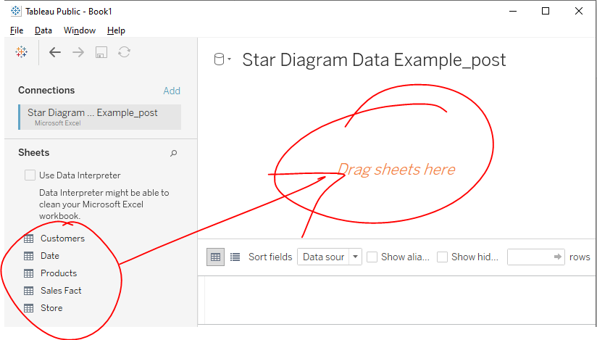

1. This will prompt Tableau to scan this Sales Fact table a provide the following (see below): 1) number of fields and rows, 2) a textbox to rename the table in Tableau if you wish, 3) a field list, and 4) a preview of the data.

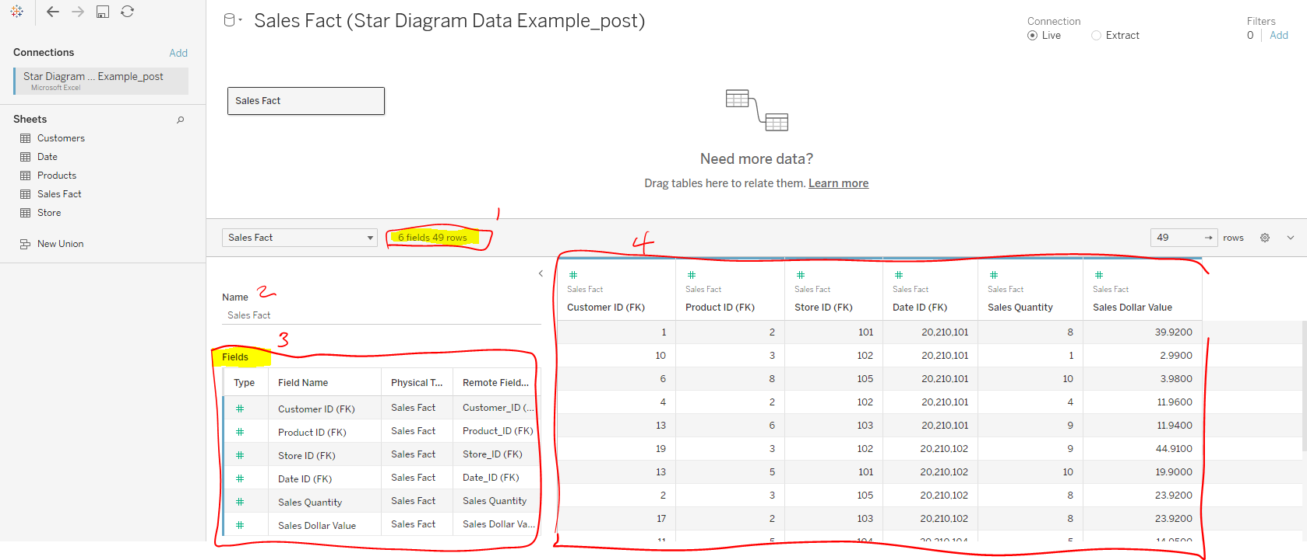

1. After you do this drag in ***Customers***, Tableau will prompt you to edit the relationship between the two tables like in ***Figure 6a*** below. Feel free to use the ERD in ***Figure 6b*** as a reference.
   1. At a minimum, Tableau wants to know on what fields you’re joining (see #1 in Figure 6a below).
   2. You can also determine the cardinality of the relationship (i.e. 1-to-1, 1-to-many, or many-to-many). (see #2 in Figure 6a below)
   3. You can also decide if you only want matching records to show up or if you would like non-matching records to show up. (see #3 in Figure 6a below). This is a way you can enact an outer join but note that Tableau also supports Left, Right, and Full-Outer join. [Read more here if you like](https://help.tableau.com/v2021.3/pro/desktop/en-us/joining_tables.htm).

|  |  |
| --- | --- |
| **Figure 6a – How to join datasets** | **Figure 6b – Data model for Sales Fact** |

1. Repeat Step 6 for the remaining dimension tables but make sure you join based on the right keys.

Note: To speed things up, you can skip the *Performance Options* settings since this dataset only contains matching inner joined records.

* 1. Relate **Dates** on **Date_ID**
  2. Relate **Products** on **Product_ID**
  3. Relate **Store** on **Store_ID**

1. Once you have the tables of your star diagram schema fully joined it should look something like this showing each dimension table inner joined to the fact table

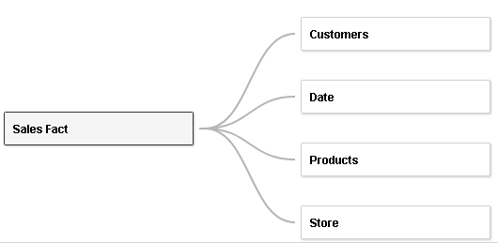

1. After this you are ready to visualize your data. Click on the “Sheet1” tab (bottom left corner) to go to your Tableau Worksheet

# Visualizing converged data in Tableau

Hypothetical: The grocery store chain thinks they get higher sales at their “Flagship” stores on holidays since they believe people like to go “all out” on holidays and shop at the bigger stores for more selection. Let’s prove this

1. In the left-hand window you’ll see you have access to **Dimensions** and **Measures**. Tableau will show you all your fields with an icon that stipulates if it’s text, date, or numeric. It also tries to guess what your measures are based on data type. Dimensions will be listed above the measures and separated by a line. Note, Tableau may guess wrong and assume some fields are measures that aren’t really things we want to measure. If this were the case you can click on the field and convert to *Convert to Dimension*. We won’t worry about this for this demo.
2. In *Sales Fact*section, drag *Sales Dollar* *Value* into the main body section (i.e. not columns or rows)

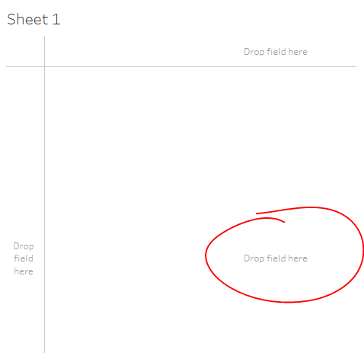

1. Now in *Date* section, find the “Holiday Flag” dimension and drag it to Columns section. Then drag the “Store Type” dimension under Store section into the Rows section.
   1. Change the measures to show the Average sales instead of the Sum. To do this, in the “Marks” window left of the data visualization, you can click down arrow in the green bubble for SUM(Sales Dollars) and select Measure > Average. Do this for both green pills because one affects the data that’s displayed and the other affects the visualization applied.

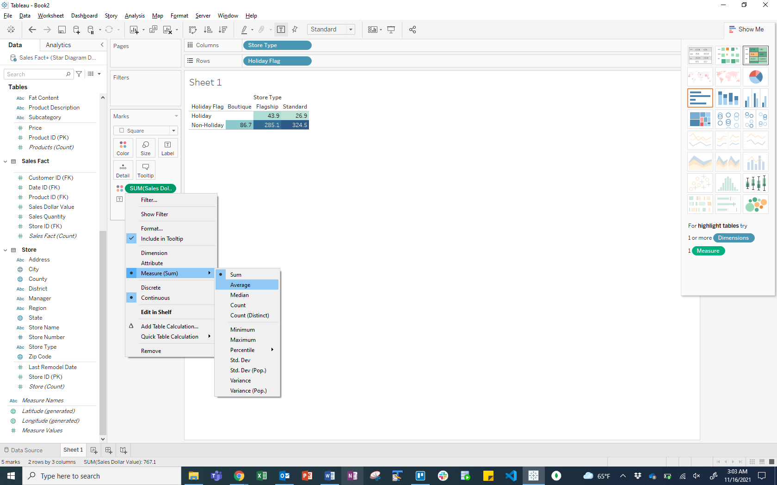

* 1. Test out some of the visualizations that are provided on the top right and see what tells a better story. *Tip: Try highlight tables*
  2. Do you see a confirmation of the grocery chain’s theory? Are flagship store sales higher on holidays?

1. Select the *New Sheet* icon to create a new data sheet for a new visualization.



1. Drag in *Sales Quantity* measure into the main body of the right visualization window like before
2. Then look at the Product dimension of “Fat Content” and the Store dimension of “City” to determine any insights on sales between these two cities stores. *Tip: Try using a* ***Side-by-Side bar*** *to compare the two cities.*
3. What next? Just go explore! Think up what you’d like to know. Then go create a new sheet, pull in the data you want to visualize, and then aggregate, pivot, and play around with different visualizations.
4. Once you have created a few good data visualizations you can create a dashboard by clicking on the “New Dashboard” tab.



# More Analytics with public datasets

This exercise will have you look through some public Tableau dashboards to learn about Tableau, data visualization, and reporting tools.

**COVID-19 Data Hub Global Tracker**

Example of multiple different ways of presenting information:

<https://public.tableau.com/views/COVID-19DataHubGlobalTracker/US?:language=en&:embed=y&;publish=yes&:origin=viz_share_link&:toolbar=n&:display_count=y>

Find the following visualizations and note what types of data they are visualizing:

* Geographic maps
* Line graphs
* Dropdowns for selecting specific states
* Options for time series

On some of these charts you can **drill down** by state or time or you can **roll-up** to a national level.

**COVID-19 Vulnerability Measures**

<https://c19hcc.org/resource/vulnerable-population>

Example of slicing on different measures. With this dashboard, you can see the following:

* Many different vulnerability measures, as the main variable being depicted in the map
* Bottom right chart: Vulnerability Index Percentile (x-axis) vs. Population (y-axis) with county being the z-variable
* **Slice** exists at date
* **Dice** to Texas
* **Drill down** to county

See what you have done here? You have **sliced**, **diced**, and **drilled** **down**! Now, what would it mean to be able to **drill** **through** or **roll-up**?

**COVID-19 Analysis**

The following dashboard has been sliced. What variable/measure is it being sliced on? What are the variables/measures in this visualization? Note that this is a multi-dimensional cube underlying this visualization (meaning that there are more than three measures being represented).

<https://public.tableau.com/profile/tom.christian#!/vizhome/CovidAnalysis_15855822218030/COVID-19>

|  |  |  |  |  |  |  |  |  |  |  |  |  |  |
| --- | --- | --- | --- | --- | --- | --- | --- | --- | --- | --- | --- | --- | --- |
| |  |  | | --- | --- | | **Example 3 – Global Spread – Multidimensional cube** | | | Variable 1 (x-axis) | **Provide Answer here** | | Variable 2 (y-axis) | **Provide Answer here** | | Variable 3 (labels – not included in slice visual!) | **Provide Answer here** | | Sliced on | **Provide Answer here** | | What is the point being made? | **Provide Answer here** | |  |

**Tennessee COVID-19 Dashboard**

<https://public.tableau.com/profile/jason.may4784#!/vizhome/TNCOVID/TNCOVIDCases>

How would you label this cube based on the Tennessee dashboard? What are the different dimensions for the chart on the top right?

Hint: we have the x-axis, the y-axis, then the colored aspect of the bar as the 3rd dimension

What do you think of this dashboard? It is not as flexible as others we have seen, because we are not able to drill down, slice, dice, or roll-up. That has already been done!

Note that data analysts who work with visualizations have the job of determining how much of their visualization should be static and how much should be able to be changed. Tableau is best utilized with the more intense dashboards we have seen earlier in this exercise! With this one, the creator decided to make a fairly static dashboard, though you can drill-down by clicking the **…** in the top right.

**Provide Answer here:**

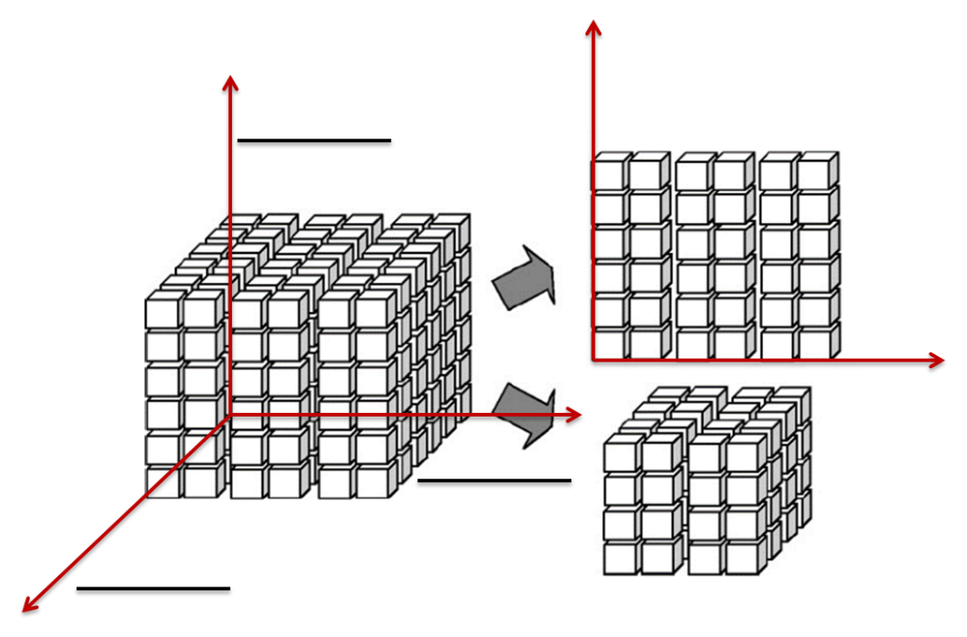

# **Above and Beyond:**

## Want to keep going?

* See all the public visualizations for Tableau here: <https://www.tableau.com/learn/articles/free-public-data-sets>
* Here are a bunch of dashboard examples to show you want it possible: <https://www.tableau.com/data-insights/dashboard-showcase?build=20213.21.1018.0949&edition=pro&lang=en-us&platform=windows&version=2021.3>
* If you want to tinker more, go download a free dataset from Kaggle and see what kind of visualizations you can create! <https://www.kaggle.com/datasets>

## More on Tableau

* Getting Started - <https://help.tableau.com/v2021.3/pro/desktop/en-us/gettingstarted_overview.htm>
* Building Charts and Analyzing Data - <https://help.tableau.com/v2021.3/pro/desktop/en-us/design_and_analyze.htm>
* Creating Dashboards - <https://help.tableau.com/v2021.3/pro/desktop/en-us/dashboards.htm>
* Creating Stories - <https://help.tableau.com/v2021.3/pro/desktop/en-us/stories.htm>